TIPS ON FLOWCHARTS AND DRAW.IO

# CONTENTS

________________________________________________________________________________

## FLOWCHARTS

* Introduction
* Basic Notations And Simple Flowcharts
* Modulus and more

________________________________________________________________________________

# INTRODUCTION

* A flowchart is a drawn or graphical representation of any algorithm
* An algorithm is a sequence to solving a problem
* A flowchart is so called because of the flow of the chart in order of the sequence of the algorithm
* flowcharts has it’s own rules and notations

# BASIC NOTATIONS AND SIMPLE FLOWCHARTS

* + It denotes the start and end of the flowchart

INPUT / OUTPUT BOX

* + it’s used when an input is needed from the user and also to display an output to the user

PROCESS BOX

* + this is for any mathematical calcualtions in your flowchart

CONDITION

BOX

* + this is needed for checking conditions

ARROW

* + this is used for connecting all the shapes in the flowchart to show the flow of logic
  + this is used for connecting one point of the flowchart to another

## example 1:

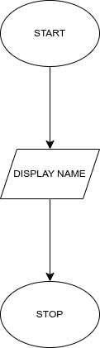example 1: displays a name

## example 2:

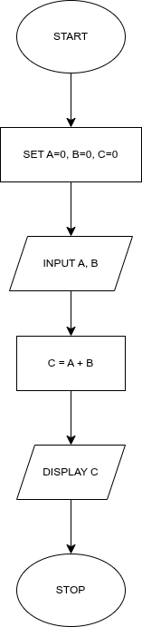Display The Sum Of Two Numbers

# MODULUS AND MORE

* When working on other mathematical operations, all you need to change is the process box
* modulus is denoted as MOD
* modulus gives you the remainder after division in integerss

## example 3:

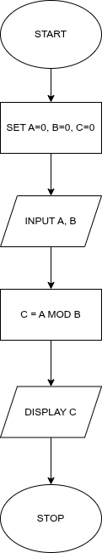

# VARIABLES AND DECISION BOX

* A variable is a placeholder for data

## example 4:

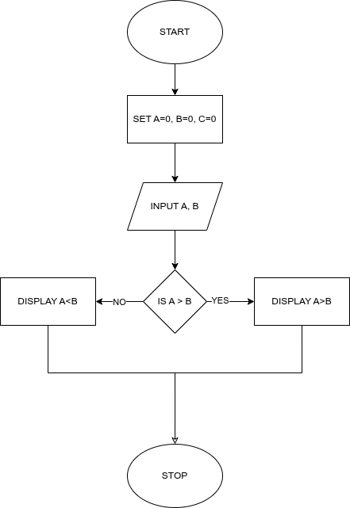

# LARGEST OF 3 NUMBERS

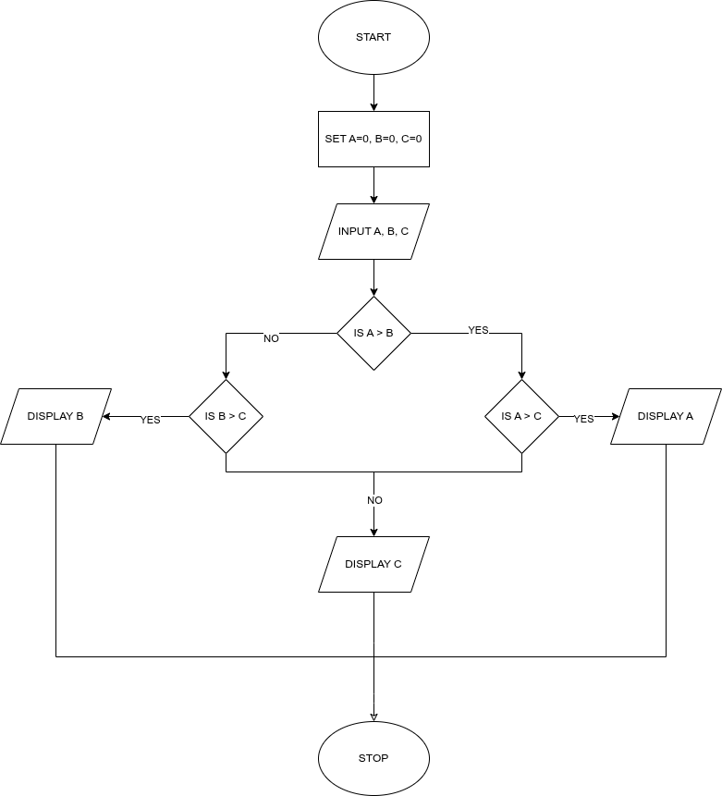

# INTRODUCTION TO LOOPS